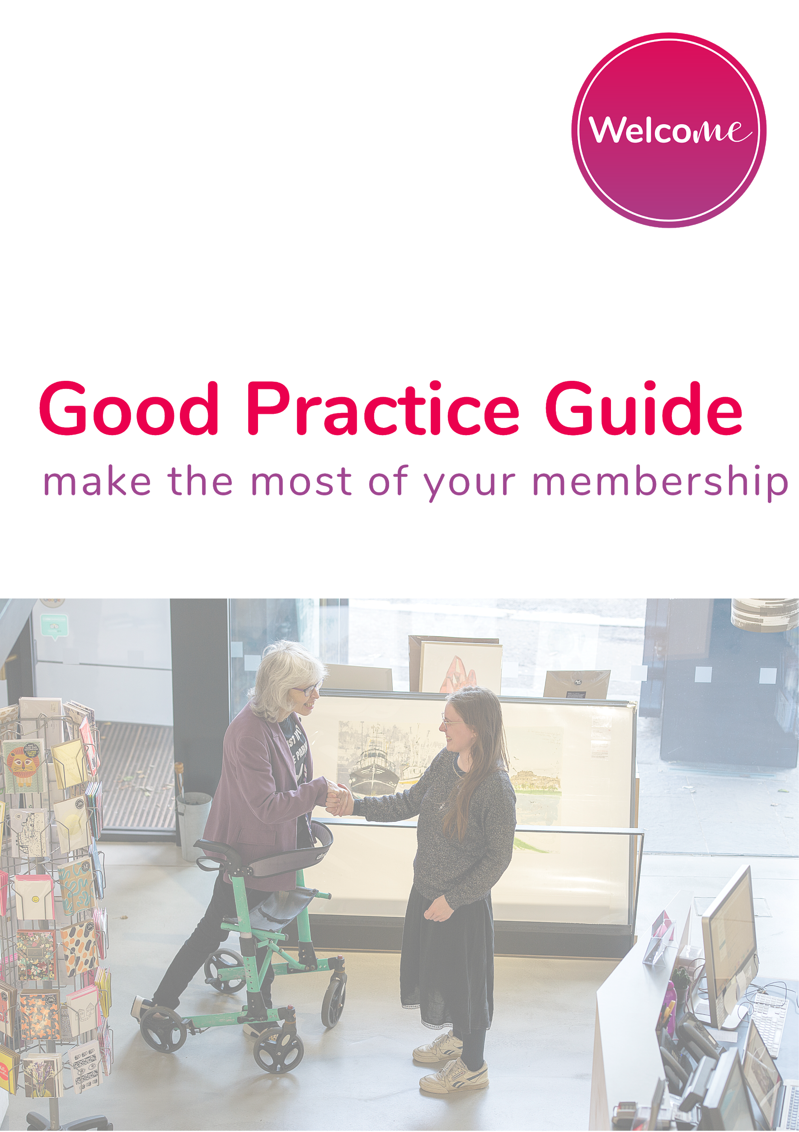

Welcome Platform
Good Practice Guide

We have designed Welcome to be easy to use but we know that it isn't always easy to get used to new systems. To help you we are keen to help as much as possible. You can, of course, drop us a line but here are our top tips to hit the ground running.

DAY TO DAY PRACTICES

● Ownership

We recommend that you or one or more staff members take responsibility for opening the system at the start of every day. You will receive notifications when people book and as they approach but it is important to keep a watchful eye.

● Information

Please ensure that the staff member looks at the overview, top tips and the specific message from the visitor. If their message is repeated back to them their trust in the system and your service team will build dramatically.

If a visit has been arranged for that day, please use the opportunity to upskill all staff members on that person and their general and specific

needs as they may well meet them or other customers with the same condition at some point in the future.

On the day of the visit, do try to put into practice as much as possible the advice given. Disabled people seldom receive this type of attention and understanding and by providing it you will be providing them with the very best customer service they have ever received.

TRAINING PRACTICES

● Involve HR

The real beauty of Welcome is that it is available for you whenever you want it. It can be used as an induction and awareness tool for new members of staff or a maintenance platform for your more experienced team members. We recommend setting up visits internally and testing your team’s knowledge on different conditions and customer service best practice.

Watching confident staff members interact with vulnerable customers can be great but watching them become more confident in their interactions with disabled people will be

To keep your staff up to date with, setup regular training especially after launching new features on the platform.

Train your new staff that will be using the platform and share with them the link to the Get Started Guide and the link to the video of our CEO, Gavin, explaining the booking process via the app and what information retailers get on the other side. This will give a better understanding of how the system works.

Book onboarding sessions, training sessions and refresher calls as needed HERE.

MARKETING PRACTICES

● Advertise on your venue’s website

It is helpful for visitors coming to your venue to know before-hand your accessibility provisions and will often check your website for this information. Place an advert on relevant pages such as Accessibility Page, Contact Us, or Home Page.

● Encourage promotion

By adding our logo with a link to our website to email footers, and other online signatures.

This is helpful in helping people to identify your organisation as an accessible venue. This helps to passively promote you are a Welcome App venue to people that you're in contact with on a daily basis.

● Social media channels

Don’t forget to follow us on social media and tag us in your posts when you talk about us.

Ideally, it would be great if you could post about Welcome visits every time these happen to give your customers the best chance of finding out about it.

We have Social media accounts on Facebook, Twitter, Instagram and LinkedIn.

You can find more info on our Welcome Promotion Pack.

● Awards

Applying for awards in customer service is a great way to increase the visibility of your business. Because Welcome will be increasing your customer service and accessibility, it can really help you win these types of awards in your industry, gaining more exposure for your business.

We love celebrating the success of our partners and will happily promote and share any nominations and awards you might get as a result.

Send us an email to hello@neatebox.com if you want to know more.

