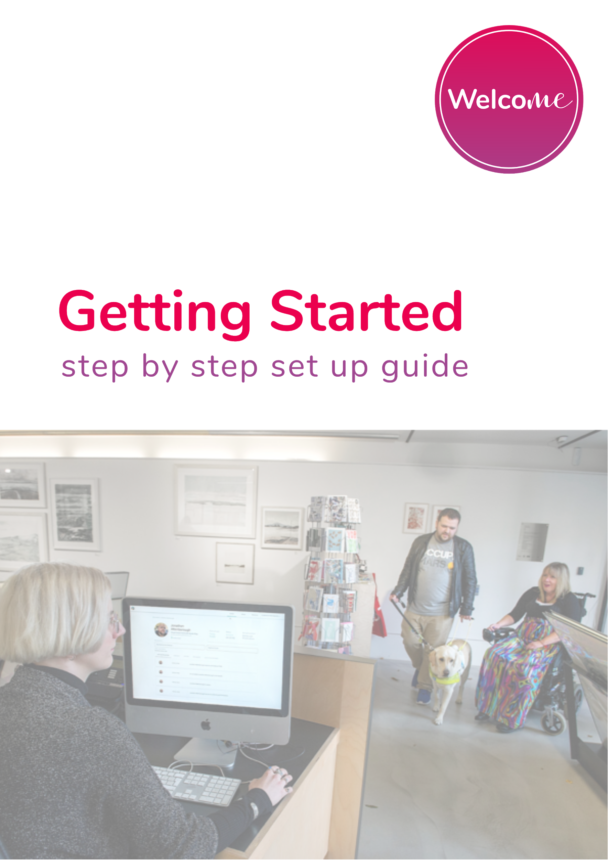

What is ‘Welcome’?

The ‘Welcome’ App is part of a new Customer Service Platform which has been designed to support customer service teams in the delivery of services for disabled visitors, whilst at the same time providing this customer with the confidence that their needs will be met on their arrival at a given location.

The immense challenge for Service Teams is to know exactly what is required of them when a person with additional requirements arrives. With disabled people travelling and living more independently than ever before it is imperative that customer service teams are comfortable offering services specific to the requirements of their customers.

‘Welcome’ alerts the Service Team of the customer’s arrival and provides both general and specific information pertinent to the visitor’s needs.

The system sends notifications at three points:

- At the moment the visitor plans a trip to your location

- As the visitor comes within a certain distance of the venue triggering a geofence (using users location services).

- As the visitor arrives at your entrance triggering a beacon installed at the entrance point.

Venue Platform Login

This guide will help you log in to the retail facing aspect of the ‘Welcome’ platform and prepare you for your first visitor.

Step 1: Open browser and go to https://welcome.neatebox.com

Step 2: Enter Your Email and Password for venue login (please find the details on the first page).

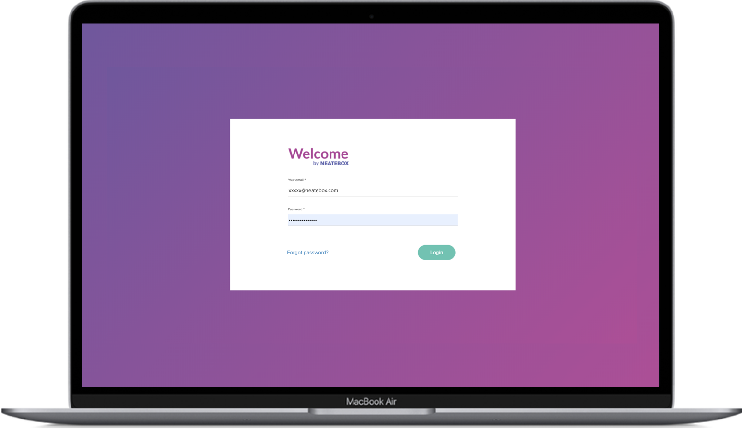

Venue Platform Main Page

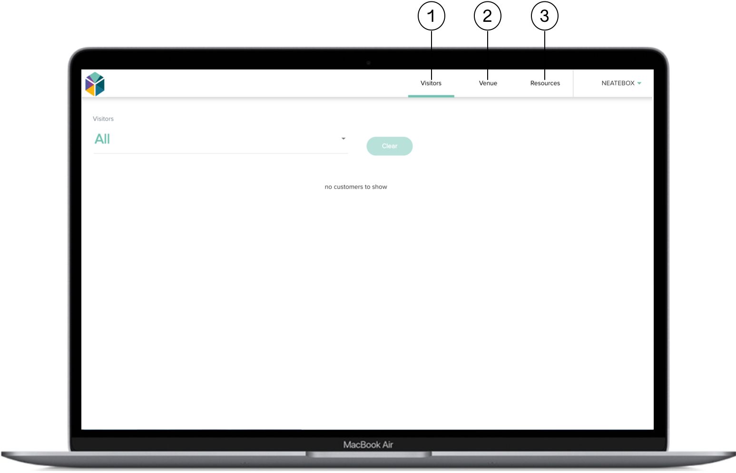

1. Visitors tab
On this tab you will see all pending visits, planned visits as well as cancelled/declined visits.

2. Venue tab
On this tab, you can see all the information about your venue that the user can see in the app. If you are a venue admin, you can update and change information, including opening hours, assistance available and general information about your venue.

3. Resources tab
The resources tab will provide extra support and links our FAQ and featured charities external links for further information on the customer’s disability. Provides a deeper dive on the charity or organisation that has provided us with support for this condition.

Venue Tab
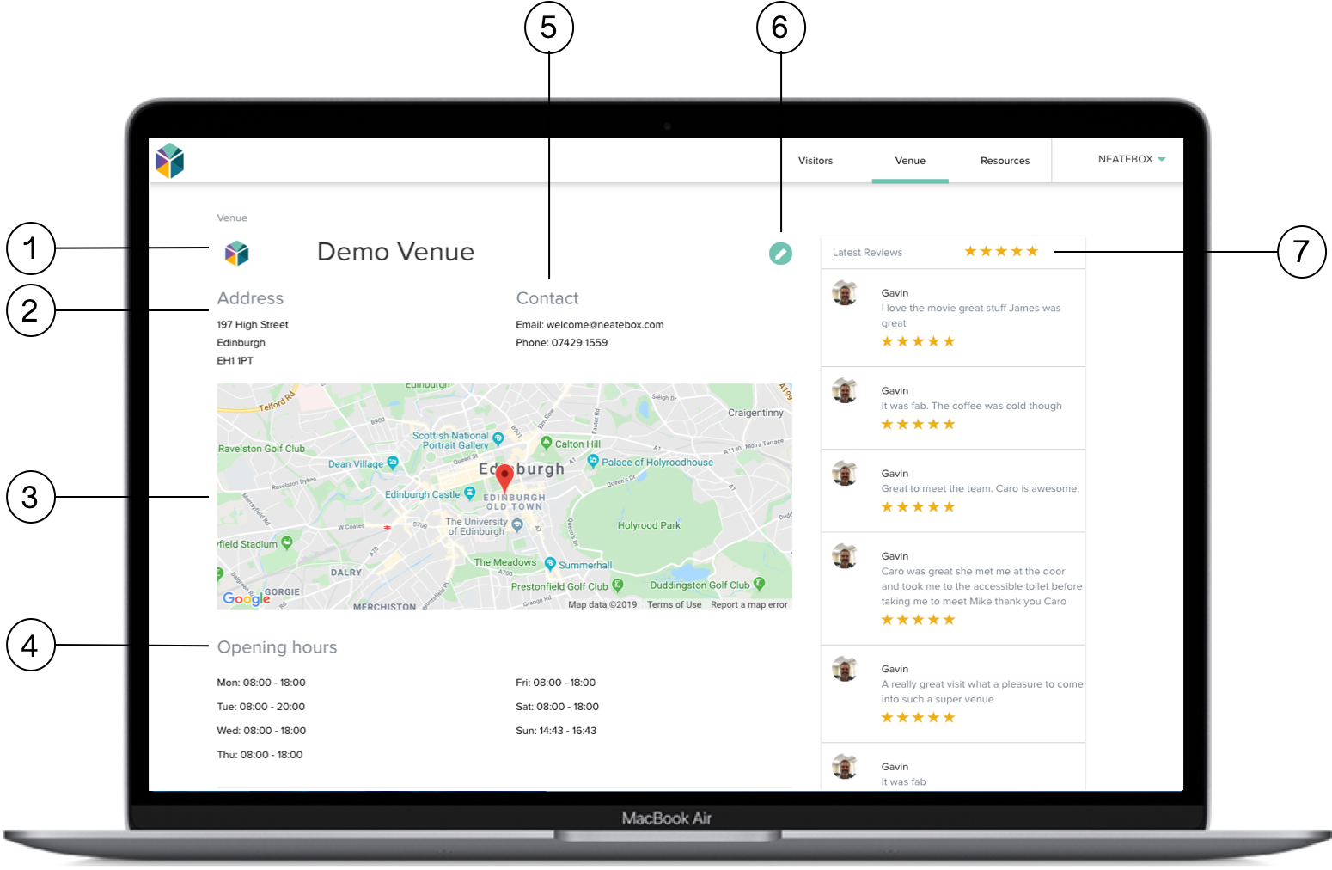

1. Logo: The venue is able to update or change their logo.

2. Address: The venue is able to update the address and postal code of the venue on this profile window.

3. Map Marker Location: The venue is able to edit the location of the marker on the map. This will be what the customer will see on their version of the app. Please notify the Welcome team if you wish to change the address.

4. Opening hours: Fully customisable opening and closing times.

5. Edit Venue Information Button: These buttons are located throughout the venue page and allow the venue admins to edit any venue information that is displayed to customers. A unique dashboard makes it easily editable by venue admins.

6. Contact: Contact information for the venue, including a telephone number. The email address will be set to welcome@neatebox.com, this shouldn’t be altered for operation purposes.

7. Latest Reviews: Customers can provide feedback from their experiences with the venue. This feedback will be private and viewable only by the venue to improve customer service and accessibility moving forward.
Please note the visitor is also signposted to disability review sites such as Euan’s Guide where they can share your good practice.

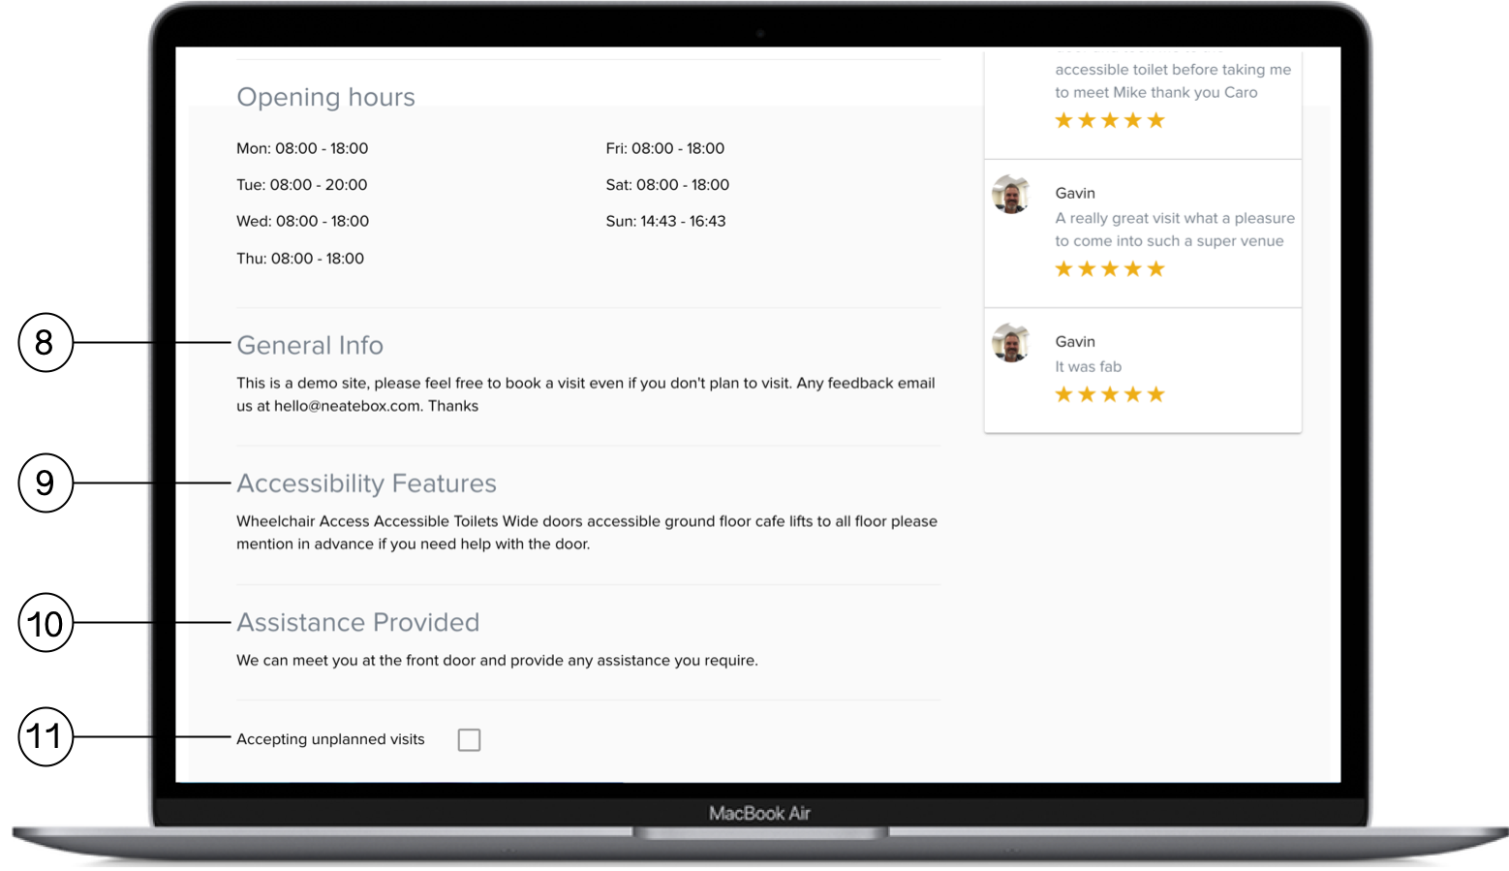

8. General Information: This section is for a short overview of your organisation and what is available at your venue. Please feel free to use this section as you wish.

9. Accessibility Features: Includes a list of the accessibility features available at your venue. We are happy to advise if you feel you do not have enough information to provide this.

10. Assistance Provided: Includes an overview of the assistance staff are able to provide. Examples of this might be that a member of staff has some BSL understanding or has been trained in Sighted Guide techniques.

11. Unplanned Visits: This will show if unplanned visits are turned on or off. This can only be altered by the Welcome team, please get in touch if you wish to change it.

Visitors Profile Page

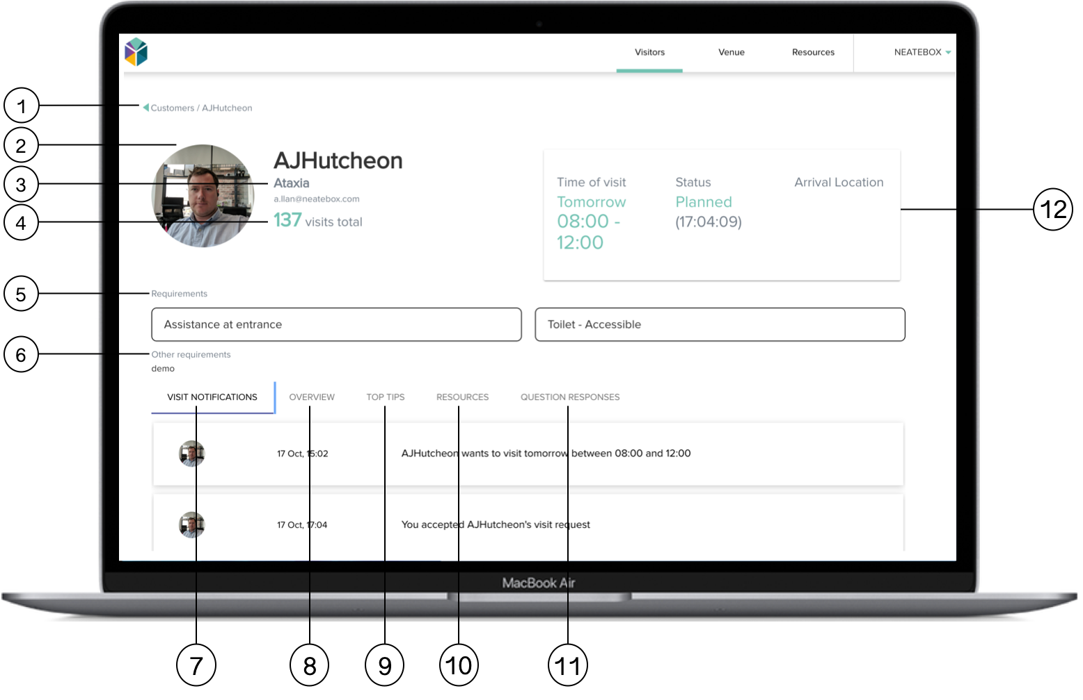

1. Return to Customer Page: After viewing the Customer Profile Page this button provides a route back to the previously viewed page.

2. Customer Profile Image: Includes a photograph of the customer.

3. Customer Profile Details: Here you will find the customers basic details including their contact email address.

4. Number of Visits: This number will indicate how many times this customer has visited your venue. This is helpful so staff can check if someone else has helped this specific customer before.

5. Requirements: This window will allow the staff to view any specific accessibility requirements like ramps, BSL instructors, etc. There is also an option to submit custom needs like “Please help me to find the milk” etc.

6. Other Requirements:
Here the customer will add additional information regarding the requirements they have for their visit to your venue.

7. Visit Notifications: This will show you the status of the visit.

8. Overview: This tab will give any information required for the staff to better understand the customer's disability with a brief overview of the condition.

9. Top Tips: Top tips will be provided on the customer's disability. These tips are provided by leading charities in the disability sector. In some cases, a URL will be provided in the top tips area to learn more when the staff have time.

10. Resources: The resources tab will provide external links for further information on the customer’s disability. Links to the disability charity that has provided the overview and top tips.

11. Question Responses: Custom Questions is a new feature which will allow the venue to ask questions to their customers related to their visit.

12. Time of Visit and Status: The green number to the left of the box will indicate the customer’s “Time of Visit”. The text to the right will indicate the status of the visitor (i.e. Late, Cancelled or On Time.)

